 | RETRACTABLE ROOF QUESTIONNARIE
1 | Type of System
2. | Floor Mount Roof / Both side wall mount roof/Wall + Floor mount roof / Balcony Enclosure/Pool Enclosure | Photo
3. | Type of Movement | Telescopic Sliding / Single Panel
4. | Dimension of Roof/Enclosure -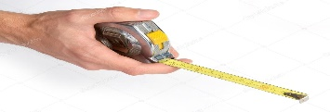 |  |  |  | Inner Dim’s |  | Outer Dim’s
4. |  | Length
 |  | Width
 |  | Height
5. | Type of Operation | Manual | Motorised with Remote |  |  |  |  |  | Control Switch
6. | Enclosure Opening Option | Partial Opening |  | Full Opening  Available Stacking Space |  |  |  | Centre  Opening |  |  | Side  Opening
7. | Polycarbonate | Clear Compact |  |  |  | Compact Embossed |  |  |  | Bronze Clear/Embossed
7. | Polycarbonate | 100% Clear
8. | Colour of Polycarbonate | Blue colour/Brown colour/Green colour
9. | RAL colour shade
10. | Site Photograph/CAD file
11. | Gutter Requirement
12. | Material lifting Floor
13. | Civil Leakage points

*Track Width – 100 mm each track
*Motor Spacing with Bus bar – 350 mm to 400 mm
*Retractable roof/Pool Enclosure maximum span– 12000 mm
*Wall mount Enclosure maximum span- 9000 mm

